Making the Transition from 2D
By Neil Munro

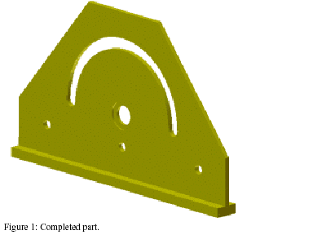

Figure 1: Completed part

One of the challenges when moving from a 2D environment, such as the one in AutoCAD®, to 3D modeling in Autodesk Inventor™ is learning the different thought process required to build rather than document a model. In fact, you may have an easier time of it if you've got little or no 2D AutoCAD experience because you lack the ingrained {zakorenene} habits of good 2D designers. The accompanying {doprovazejici} tutorial, New to Autodesk Inventor™, leads you through planning and creating a simple part model in Autodesk Inventor. The tutorial highlights some of the areas where you may need to think outside the AutoCAD "box" to be proficient {dovedny} with Autodesk Inventor.

Three Words: Planning, Planning, Planning
As with most things, a little planning goes a long way. The process of building a 3D part model typically involves {zahrnuje} a series of operations that either add material to, or remove material from, the model. There are many exceptions to this process, but the following steps comprise much of the workflow {prubeh prace} for many part models:
1. Create a closed-profile 2D sketch.
2. Add some rules (constraints {omezeni} and dimensions {rozmery}) as to how the sketch entities should behave.
3. Create a 3D solid from the sketch by either extruding {tvarovat} the sketch perpendicular to the sketch plane, or revolving the sketch about an axis on the sketch plane. The resulting solid {teleso} can add or remove material from the part.
4. Repeat as necessary.

The biggest problem is often where to start. Well, since the part will be modeled as a series of features, break it down into Autodesk Media and Entertainment features. Identify the one shape that best describes the part's form. That shape is usually a great candidate for your first sketch and feature.

Figure 2 shows the part exploded {rozlozeny, rozdeleny} into features. The image on the left shows the part starting with a sketch and extrusion {vystrceni} of the plate outline. The image on the right shows the part starting with an extrusion of the T-shaped sketch. The feature created from the initial sketch is shown in gold; features that remove material are shown in red; and the feature that adds material is shown in blue. Note that the bottom rail is not included in the first extrusion in the left image; that's because it's a different thickness than the plate. There are advanced techniques you can use to overcome this, but better keep it simple when creating your first models.
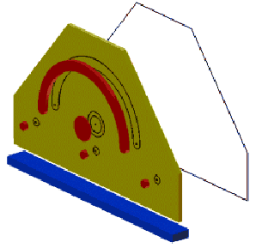
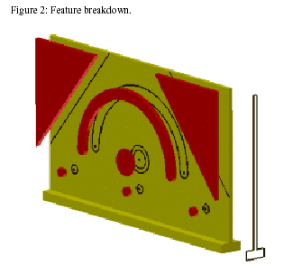

Figure 2: Feature breakdown
If you were using AutoCAD software to document this part, you would likely start with the view of the face with the chamfered corners. In addition, the view would probably be drawn entirely in the positive XY quadrant of the WCS. It is also likely that you would draw entities from left to right and use symmetry where appropriate. When building a 3D model, using symmetry is important for efficient and robust designs.

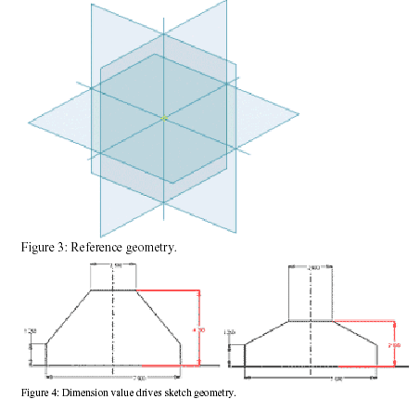

Figure 3: Reference geometry

A new part file contains default reference geometry (planes, axes, and center point). It is good practice to build models around this geometry, aligning critical geometry with the reference axes or center point. You must project reference geometry into your sketch before it can participate in the sketch. Adopting a more "center-out" design philosophy will lead to the creation of robust 3D models.

Figure 4: Dimension value drives sketch geometry

AutoCAD 2D vs. Autodesk Inventor 2D
A drawing view created in 2D AutoCAD consists of precisely created geometry representing edges, points, and so on. To reduce the chance of being frustrated during sketch creation, you have to let go of the good 2D habit that everything must be drawn exactly. Unlike AutoCAD associative dimensions that can track changes to the underlying geometry, dimensions added to Autodesk Inventor sketches drive the size of the sketch geometry. Editing a sketch dimension value changes the size or position of the referenced geometry (Figure 4).
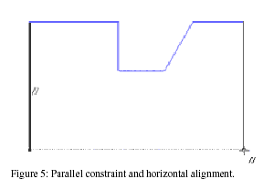

Figure 5: Parallel constraint and horizontal alignment

Because changing a dimension value modifies the geometry, you can get some interesting results if the value change is large. Sketching roughly to scale reduces the chance of odd editing behavior. Use the following as a guide to editing sketch dimensions.

Modify dimensions in the following order:
- big dimensions that will be made bigger
- small dimensions that will be made smaller
- small dimensions that will be made bigger
- big dimensions that will be made smaller

In addition to dimensions, other rules govern the relationship between sketch entities. Geometric constraints, such as parallel, concentric, and coincident, are added among lines, curves, and points as you sketch. You can infer horizontal or vertical alignment to points, or change the entity referenced in a geometric constraint, by moving the cursor over desired geometry (without clicking it).
See Figures 5 and 6.
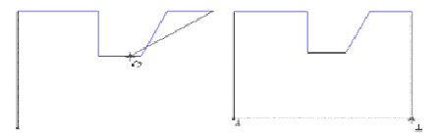

Figure 6: Infer other geometry (left); perpendicular constraint (right).

You can manually add geometric constraints. You can also delete constraints that may be enforcing rules that are no longer required. Where possible, add geometric constraints instead of using multiple dimensions.

Three More Words: Testing, Testing, Testing

Autodesk Inventor indicates the state of sketch geometry by color. As rules (constraints and dimensions) are added to a sketch, the orientation and size of entities become fixed. As long as you are renouncing AutoCAD habits, you might as well pick up this Autodesk Inventor habit: drag underconstrained geometry (curves, lines, end-points of those lines, and so on) to determine how the geometry can change. The additional constraints and dimensions required are usually readily apparent. See Figure 7.

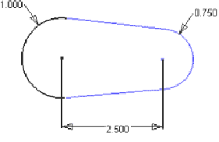
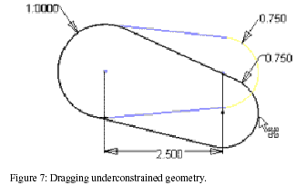

Figure 7: Dragging underconstrained geometry
There are instances where some sketch geometry is intentionally left in an underconstrained state (e.g., when using adaptive features). This usually involves leaving out one or more sketch dimensions.

Keep It Simple
Because an AutoCAD 2D drawing view may contain all the part edges visible in the view, you may assume it is good practice to add all these edges in the first feature sketch in an Autodesk Inventor part file. It is not. Resist the urge to define every possible feature in the first sketch. Simple sketches are far easier to constrain and tend to create models that are easier to maintain. As you gain experience, you will learn where and when to add complexity to a sketch.

Summary
To sketch efficiently using Autodesk Inventor:
- Keep your sketches simple. Once you are comfortable with the sketching process, investigate more complex sketches and the concept of sharing sketches.
- Sketch features roughly to size and shape but don't try to be too precise. This is especially true for the first feature sketch in a part. It is easier to judge the scale of subsequent features relative to existing geometry.
- Use construction geometry to help position and size normal sketch geometry. Construction geometry is not considered when a solid is created from the sketch. It can reduce the number of dimensions required and the need for equations between sketch dimensions.
- Infer relationships while sketching by moving the cursor over the point, line, or curve you want to reference. Keep track of the geometric constraints placed as you sketch. Add additional geometric constraints as required.

Fully constrain sketches unless the feature derived from the sketch will need to adapt. Experiment—it's fun!

© Copyright 2005 Autodesk, Inc. All rights reserved.

Vocabulary.

      - Look up the words in the dictionary. Translate them into Czech.
Tutorial - google: konzultace, cviceni
workflow - prubeh prace
sketch - nakres, skica
constraints - omezeni
to constrain - omezit
dimensions - rozmery, velikosti, kóty
to extrude - vytlacit, vyloucit, vytekat
perpendicular - kolmy
solid - pevny, dulezity
plate - plát
chamfered - vykrojený
plane - plán
edge - hrana
to track - stopovat
underlying - zakladni
to drive - ridi
concentric - soustredny
coincident - shodny
to infer - odvodit
alignment - zarovnani
underconstrained - “mit mene omezeni nez by melo mit”
X overconstrained - “mit vice omezeni nez by melo mit”
to distort - prekroutit
stacked - zaplneny
drag - odvozeny
WCS

      - Complete the text with the given words.

relationships dimension features constraints center advantage edge geometry

What is Parametric Sketching

Depending on a part’s form, fit, or function, certain features of the part have quantifiable relationships with other features of the part. For example, holes are a certain distance apart, or an edge is half as long as another edge, and so forth. Parametric sketching provides a method to maintain and take advantage of these relationships in your sketches and in your parts.
Designers use parameters, equations, dimensions, sketch geometry, and construction geometry to define these constraints For example, placing a edge between two points creates a relationship between those two points. Because of this relationship, the two points are always that distance apart, even if one of the points is moved. This is a simple example of design intent.
(See Fig.1 Point B will always be 44 mm from Point A.)
By projecting relationships from previously created features, you create a relationship between features. For example, by projecting the outer dimension of a circular feature and sketching a new circle with a common center point, you relate the new circle to the original circular feature of your part. (See Fig. 2 The sketched circle is related to the projected circle.)
To use equations to determine relationships, you specify mathematical relationships between dimensions. For example, you specify the length of a rectangle as being twice the width.
(See Fig.3 Line B is twice as long as Line A)

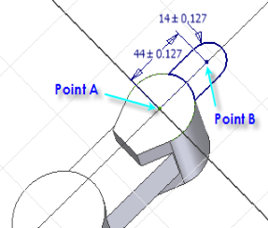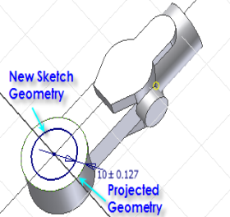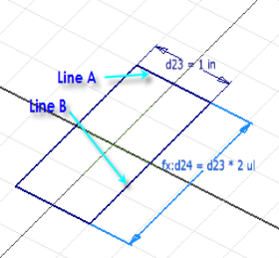

- Text comprehension.

      - Decide whether the following statements are true or false.

- The best beginning is to state how many holes the part’s form has. False
- Reference geometry is not appropriate when creating a new part file. False
- Reference geometry must not be projected into your sketch before it can participate in the sketch.
False
- It is good to preserve all good habits, i.e. exactness, as learned in 2D projecting. False
- Dimensions added to Autodesk Inventor sketches drive the size of the sketch geometry. False
- Sketching precisely to scale reduces the chance of odd editing behavior. True
- It is good practice to add all visible edges in the first feature sketch in an Autodesk Inventor part file. False
      - Answer the questions.
- What is the main task in 3D modeling in Autodesk Inventor™?
- What three words describe the steps of the workflow? What are the steps of building a 3D model?
- Examine the part in Figure 1. What would your choice be for the feature that defines the part?
- What does Fig. 2 represent?
- Why is the bottom rail not included in the first extrusion in the left image?
- How could you draw the view of the face with the chamfered corners?
- How do AutoCAD associative dimensions behave?
- What happens when editing a sketch dimension value?
- What further rules can influence the relationship between sketch entities? How can you work with them?
- Name some geometric constraints
- What is the advantage of using underconstrained geometry?
- What are the main principles of sketching efficiently using Autodesk Inventor?

- Change the instructions to the right order.
- small dimensions that will be made bigger
- big dimensions that will be made bigger
- big dimensions that will be made smaller
- small dimensions that will be made smaller

      - Now, Think About This...
Write down your suggestions.
Examine the three versions of the shaft shown in Figure 8.
The left image has the shaft modeled as a series of stacked cylinders (all shafts have been split for clarity). The middle image shows a single sketch revolved around an axis. The image on the right mimics the real-world process: a piece of cylindrical bar stock is machined into the finished form (red tubes subtracted). Which approach would you use? Perhaps you have some other method?
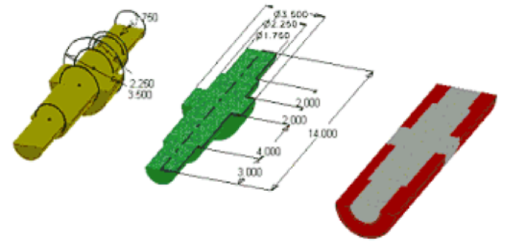

Figure 8: Modeling methods

- Grammar.

- Practicing relative clauses in definitions.

A. Study.
Sketching and Drawing
Parametric sketching and drawing are not the same; each has a different purpose.

A drawing is a collection of geometry (lines, points, and arcs) laid out in a 2D format.
These geometric elements, which have no relation to each other, are used to determine the final prints.

A sketch is a collection of geometry (lines, points, and arcs) coupled with relationships (parameters, equations, dimensions, sketch constraints, and construction geometry) laid out in a 2D format. These geometric elements are related to each other to reflect design intent. These sketches are used to define 3D geometry, which is then projected to 2D for the final prints.

B. And now define both terms using full forms of the relative clauses.

- Study the following -ing forms.
Replace the present participles with full forms of the relative clauses.

- The image on the left shows the part starting with a sketch and extrusion of the plate outline.
- A drawing view created in 2D AutoCAD consists of precisely created geometry representing edges, points, and so on.

See the explanations and do all relevant exercises in the grammar packet called “Grammar Focus_Infinitives and -ing Forms.” Your task for this lesson will concern:
-ing Clauses

-ING FORMS

Look at the chart:

Adjective  measuring devices | Verbal noun  the accurate measuring of
Gerund  (in) measuring pressure accurately | Participle  He was measuring the pressure.  Measuring the pressure, he observed the values.  Having measured the pressure, he put the values down.

- What do the categories have in common?
- There are some important differences. Can you find them?
- Read the article to complete the chart with further examples.

Notice some examples of translation:
GERUNDS:
Instead of being isolated, the inventions appeared at times of both demand and supporting technology.
Místo toho, aby zůstaly stranou pozornosti, tak se tyto vynálezy objevily v době poptávky a podpůrné technologie.
PARTICIPLE:
Judging by the book experience, the censorship will be with us for some time.
Soudě dle zkušeností s knížkami, cenzura nás bude ještě nějaký ten čas provázet.

- Read the article again and find at least 2 examples of gerunds and 2 examples of participles.
- Translate these examples together with the context.

Remember! The gerund is more frequently used than the verbal noun.

I. Replace the verbal noun with the gerund.

- The writing of letters was always boring for me.
- The measuring of current is provided by measuring devices.
- The bank also offers the keeping of accounts.

- .....................................................................................................................................................
- .....................................................................................................................................................
- .....................................................................................................................................................

II. Translate the sentences and see how the ways of translating are different.
- Your staying here is advisable. (by noun)
- Seeing is believing. (by infinitive)
- The play is worth seeing. (by verbal noun)
- He passed her without greeting her. (by subordinate clause)

REMEMBER ! In most cases, Czech prefers a subordinate clause and vice versa, Czech subordinate clauses are very often translated by gerunds!

- .....................................................................................................................................................
- .....................................................................................................................................................
- .....................................................................................................................................................
- .....................................................................................................................................................

III. Translate using gerunds.
- Protestuji (to object to) proti tomu, aby mi někdo četl dopisy.
- Byl zvyklý na to (to be used to), že ho lidé obdivují (to admire).
- Odešel bez pozdravu (bez pozdravení; aniž by pozdravil).
- Jsem unaven častým čekáním.
5) Předtím, než je vám povolen vstup do letadla, musíte ukázat svůj palubní lístek.

- .....................................................................................................................................................
- .....................................................................................................................................................
- .....................................................................................................................................................
- .....................................................................................................................................................
- .....................................................................................................................................................

- Now you… HW

- Write a summary of the crucial points from the article.

- Translate into Czech.

- One of the challenges when moving from a 2D environment, such as the one in AutoCAD®, to 3D modeling in Autodesk Inventor™ is learning the different thought process required to build rather than document a model.
- Create a 3D solid from the sketch by either extruding the sketch perpendicular to the sketch plane, or revolving the sketch about an axis on the sketch plane.
- Adopting a more "center-out" design philosophy will lead to the creation of robust 3D models.

- .....................................................................................................................................................
- .....................................................................................................................................................
- .....................................................................................................................................................

Presentation topic.
Some tips for you.

Geometric dimensioning and tolerancing.

